**Lab 4: Inserting Initial Data into the Database**

**Program_Lab4_Insert.cs**

using System.Text;

using Microsoft.EntityFrameworkCore;

using RetailStoreLab2;

using RetailStoreLab2.Models;

class ProgramLab4

{

public static async Task Run()

{

Console.OutputEncoding = Encoding.UTF8;

using var context = new AppDbContext();

context.Products.RemoveRange(context.Products);

context.Categories.RemoveRange(context.Categories);

context.SaveChanges();

Console.WriteLine("🧹 Old data cleared.");

var electronics = new Category { Name = "Electronics" };

var groceries = new Category { Name = "Groceries" };

await context.Categories.AddRangeAsync(electronics, groceries);

var product1 = new Product { Name = "Laptop", Price = 75000m, Category = electronics };

var product2 = new Product { Name = "Rice Bag", Price = 1200m, Category = groceries };

await context.Products.AddRangeAsync(product1, product2);

await context.SaveChangesAsync();

Console.WriteLine("✅ Lab 4 data inserted successfully.");

}

}

**Lab4-dotnet-run (screenshot)**

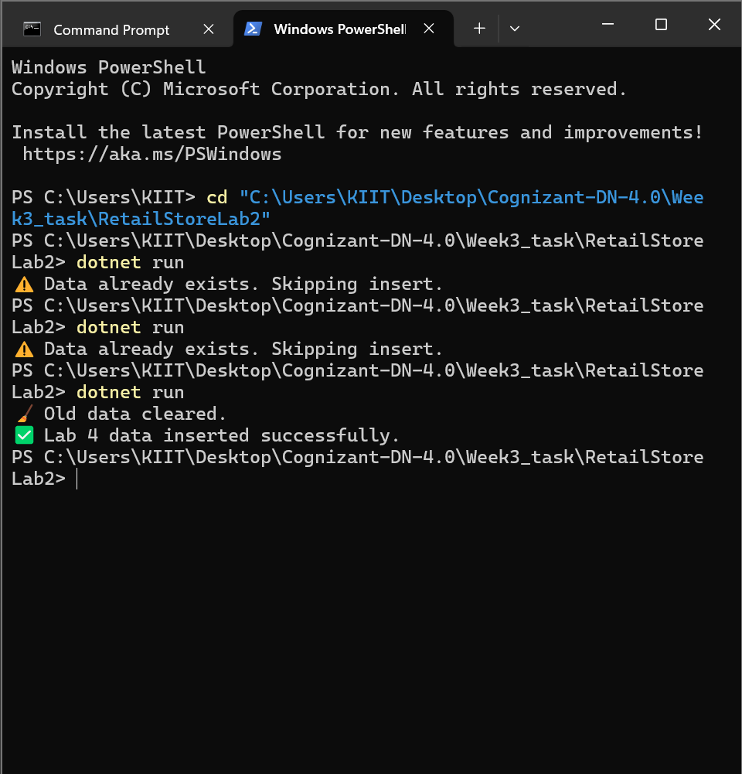

**Lab4-products-ssms (screenshot)**

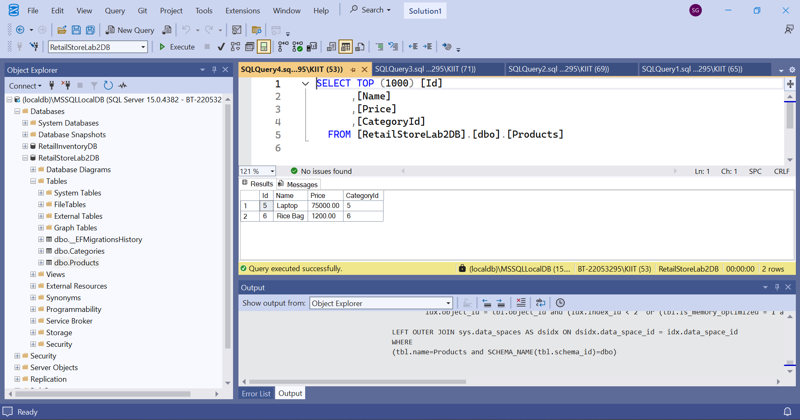

**Lab4-categories-ssms (screenshot)**

